Problem Chosen: Smart health solutions for solpaur municipal corperation
Problem Definition
Problem context
Healthcare systems today are largely reactive rather than preventive. Most of the diseases are identified only after the symptoms become noticeable. By the time patients seek medical help, the condition may be already be in an advanced stage, increasing treatment complexity and cost.
Individuals rarely undergo regular health monitoring unless they experience visible health issues. Late-stage treatments require expensive medical procedures, hospital stays, and long-term meditation.Early detection of diseases can significantly reduce complications, hospital admissions.
So, there is a strong need for a web-based smart health monitoring system for Solapur that can collect, analyze, and interpret individual health and genetic data to predict diseases risks and provide preventive recommendations. The proposed TEAM CARE AND CURE system aims to address this gap by enabling proactive and personalized healthcare management.

Objectives
- A smart health system (Care And Cure) that helps people in solapur detect the diseases early and take action in time.
- To minimize emergency health incidents such as heart strokes or suddenly occurring risks through early warning systems.
- To store health records digitally so that patients and doctors can track health history easily.
- To increase awareness about the preventive healthcare according to the individual’s health record by giving simple health tips and remainders from the concerned doctors.
- To reduce medical expences for everyone in the Solapur by avoiding costly treatments through early detection.
- To analyze health risks based on family genetical history and provide personalized guidance.
- To create awareness about preventive health care among the people of Solapur.
- To improve overall quality of life by focusing on prevention instead of treatment.

Constraints
- Low health awareness, some people may not understand the importance of regular health monitoring.
- Low health awareness, some people may not understand the importance of regular health monitoring.
- Resistance to new technology, people may hesitate to trust or adapt smart healthcare system.
- Healthcare workers and users may need proper training to operate the system.
- Data privacy and security concerns, protecting patient health data from misuse or hacking is a major challenge.
- Regulatory Approvals, the system may require approvals from health authorities before the complete implementation.
- Approval from the government or the health sectors.

Functions
- Health data collection: Collects the complete health data including genetical information of an individual of solapur.

- Continuous monitoring: Tracks health parameters regularly and record hanges in health conditions over time.

- Early Risk Detection: Detects possible health problems at an early stage.

- Digital Health record storage: Stores the patient data safely in digital form. Allows easy access to previos medical history.

- Health report generation: Creates health reports after every blood test conducted.

Early-Stage Solution Architecture
Problem Chosen: Smart health solutions for Solapur municipal corperation
List of subsystems
Sl.No | Subsystem Name | Functionality
1 | Patient Registration | Collects patient details such as medical history, and complete family genetic background.
2 | Sample Collection | Collects blood samples from patients every six months for testing.
3 | Laboratory Testing | Performs blood analysis and generates detailed test reports.
4 | Health data comparison | Compares current blood test results with previous reports and the genetic data which has been stored.
5 | Identifying the risk | Identifies the health risks based on the comparison and medical consultation.
6 | Recommendation | Recommends preventive measures such as diet plans, lifestyle changes, or any medical consultation.
7 | Report Generation | Generates easy to understand health reports for patients
8 | Monitoring | Schedules next blood test and tracks patient overall health progress over time.

Subsystems Interaction matrix
 | PR | SC | LT | GDA | RR | REC
Patient registration | Patient details | Sample collection ID | Test results | Comparing with LT results | Risk ratio(1-10%) | Final health report
Sample collection | Registration info | - | Blood sample | - | Sample data | -
Laboratory testing | Test report | Sample received | - | Test results | Lab results | Health report
Genetic data analysis | Genetic record | - | Genetic data | - | Genetic risk data | Risk support data
Risk ratio | Risk summary | - | Analysis request | Genetic analysis | - | Risk result
Recommendation | Advice to patient | - | - | - | Prevention strategy | -

Architecture Diagram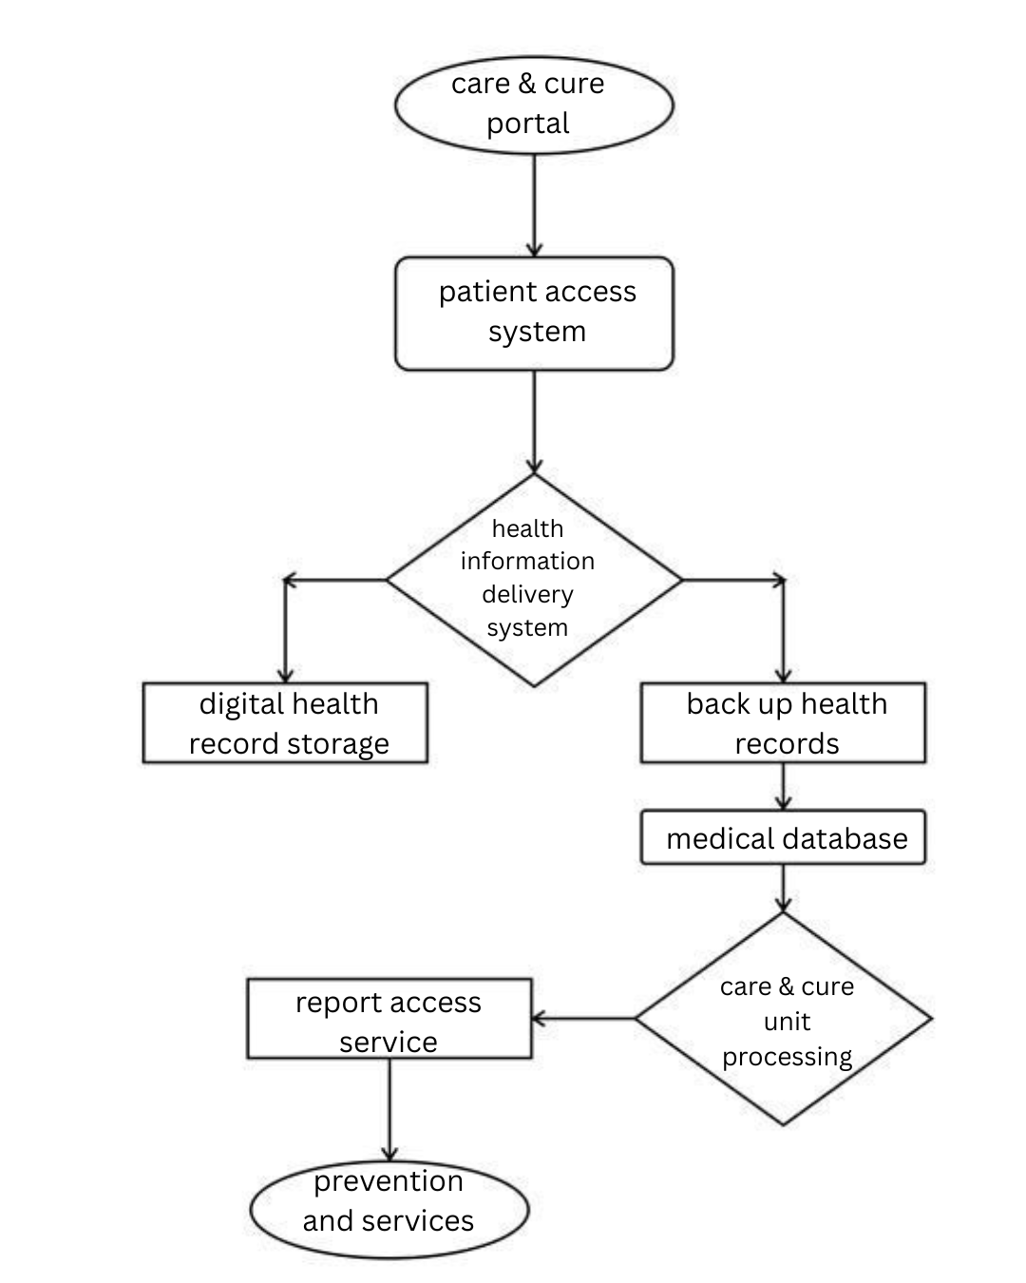

Team Information
Team name: :TEAM CARE & CURE |  |  | Institute code: QM
Institute name: KG REDDY COLLEGE OF ENGINEERING AND TECHNOLOGY
City: HYDERABAD |  |  | State: TELANGANA
Mentor Details
Mentor name: KALPANA KILARI
Contact number: 9866631592 |  |  | Email: kalpana.akkineni09@gmail.com
Participant Details
SN | Participant name | Program | Sem | Contact number | Email
1 | Chaduvula Aishwarya | BTECH | 2-II | 9642444440 | aishwaryachaduvula@gmail.com
2 | Ganapathi Karthikeya | BTECH | 2-II | 9989052374 | Karthikeyaganapathi5@gmail.com
3 | Aluka Shashi Vardhan Reddy | BTECH | 2-II | 9014721453 | Shashivardhanreddy93@gmail.com
4 | Addula Sai Harini | BTECH | 2-II | 9121680208 | Asaiharini254@gmail.com
5 | Yalala Poojitha | BTECH | 2-II | 9014199509 | Poojayalala4@gmail.com
Note: The above details will be used for certificate generation. Please ensure accuracy.
Declaration
We hereby declare that the work titled “<Problem Title>” submitted for SAMVED-2026 is the original outcome of our team’s efforts.
The work has been carried out by us under the guidance of the undersigned mentor and is neither copied from any source nor generated using artificial intelligence (AI) tools.

Place: Hyderabad
Date:20/02/2026
Team Leader Name: Chaduvula Aishwarya
__________________________
Mentor Name:Kalpana Kilari
__________________________

